**PIZZA SALES SQL QUERIES**

**A. KPI’s**

**1. Total Revenue:**

SELECT SUM(total_price) AS Total_Revenue FROM pizza_sales1;

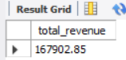

**2. Average Order Value**

SELECT (SUM(total_price) / COUNT(DISTINCT order_id)) AS Avg_order_Value FROM pizza_sales

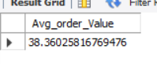

**3. Total Pizzas Sold**

SELECT SUM(quantity) AS Total_pizza_sold FROM pizza_sales

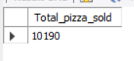

**4. Total Orders**

SELECT COUNT(DISTINCT order_id) AS Total_Orders FROM pizza_sales

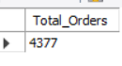

**5. Average Pizzas Per Order**

SELECT CAST(CAST(SUM(quantity) AS DECIMAL(10,2)) /

CAST(COUNT(DISTINCT order_id) AS DECIMAL(10,2)) AS DECIMAL(10,2))

AS Avg_Pizzas_per_order

FROM pizza_sales

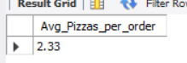

**B. Daily Trend for Total Orders**select DAYNAME(STR_TO_DATE(order_date, '%Y-%m-%d')) as order_day , count(distinct(order_id)) as Total_order

from pizza_sales

WHERE order_date IS NOT NULL

group by DAYNAME(STR_TO_DATE(order_date, '%Y-%m-%d'));

***Output:***

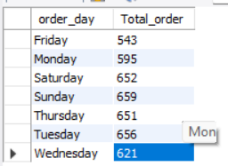

**C. Hourly Trend for Orders**

SELECT hour(order_time)as order_hours, COUNT(DISTINCT (order_id)) as total_orders

from pizza_sales

group by order_hours

order by order_hours

***Output***

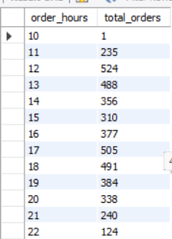

**D. % of Sales by Pizza Category**

select pizza_category ,sum(total_price)*100 / (select sum(total_price) from pizza_sales WHERE MONTH(STR_TO_DATE(order_date, '%Y-%m-%d')) = 1 ) as PCT , sum(total_price) as total_sales from

pizza_sales

WHERE MONTH(STR_TO_DATE(order_date, '%Y-%m-%d')) = 1

group by pizza_category;

***#percentage of sales by pizza_category***

***Output***

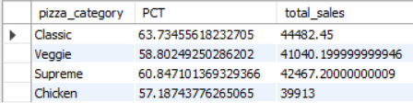

**E. % of Sales by Pizza Size**

select pizza_size ,cast(sum(total_price)*100 /

(select sum(total_price) from pizza_sales)

AS DECIMAL (10,2))as PCT ,

cast(sum(total_price) AS DECIMAL (10,2))as total_sales from

pizza_sales

group by pizza_size

order by PCT DESC;

#percentage of sales by pizza_size

Output

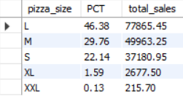

**F. Total Pizzas Sold by Pizza Category**

select pizza_category , count(quantity) as NPS from pizza_sales

group by pizza_category;

***#CATEGORY WISE COUNT OF PIZZA SOLD***

***Output***

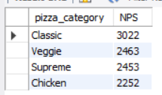

**G. Top 5 Best Sellers by Total Pizzas Sold**

SELECT pizza_name , sum(quantity) as No_of_PizzaSold from pizza_sales

group by pizza_name

order by No_of_PizzaSold desc limit 5;

Output

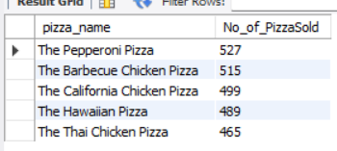

**H. Bottom 5 Best Sellers by Total Pizzas Sold**

SELECT pizza_name, SUM(quantity) AS Total_Pizza_Sold

FROM pizza_sales

GROUP BY pizza_name

ORDER BY Total_Pizza_Sold ASC limit 5;

***Output***

